Clone LL with Random and Next Pointer
Problem Statement: Given a linked list where every node in the linked list contains two pointers:
- ‘next’ which points to the next node in the list.
- ‘random’ which points to a random node in the list or ‘null’.
Create a ‘deep copy’ of the given linked list and return it.
Example 1:

Input:

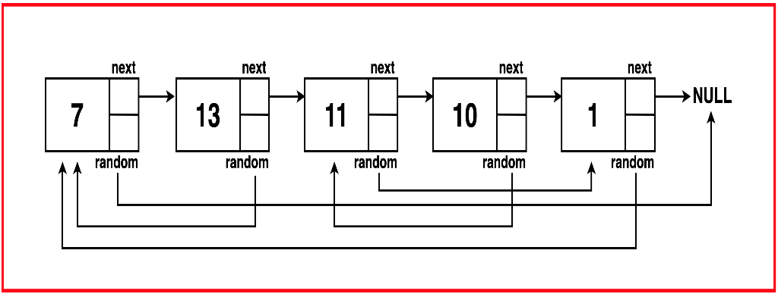

Output:

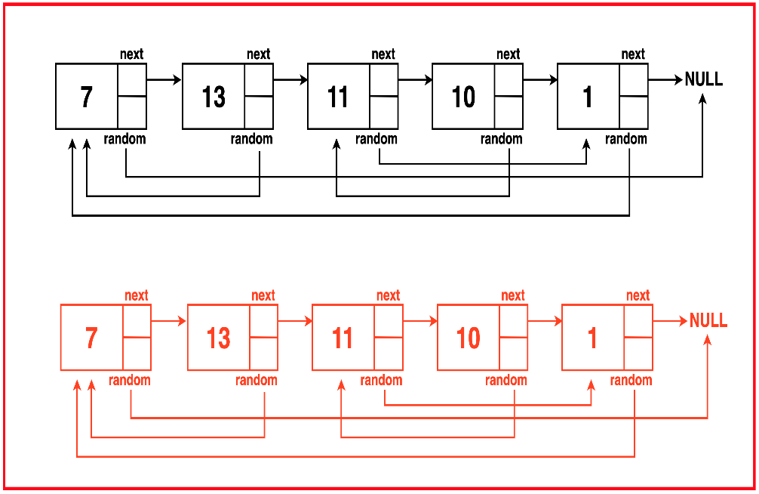
Explanation: A deep copy of the linked list has to be created while maintaining all ‘next’ and ‘random’ pointers to the appropriate new nodes. Additional memory allocation is done while creating a duplicate set of nodes and managing their pointer relationships.
Algorithm
Instead of creating duplicate nodes and storing them in a map, insert it in between the original node and the next node for quick access without the need for additional space.
Traverse the list again to set the random pointer of copied nodes to the corresponding copied node duplicating the original arrangement. As a final traversal, separate the copied and original nodes by detaching alternate nodes.
Algorithm
Step 1: Traverse the original node and create a copy of each node and insert it in between the original node and the next node.
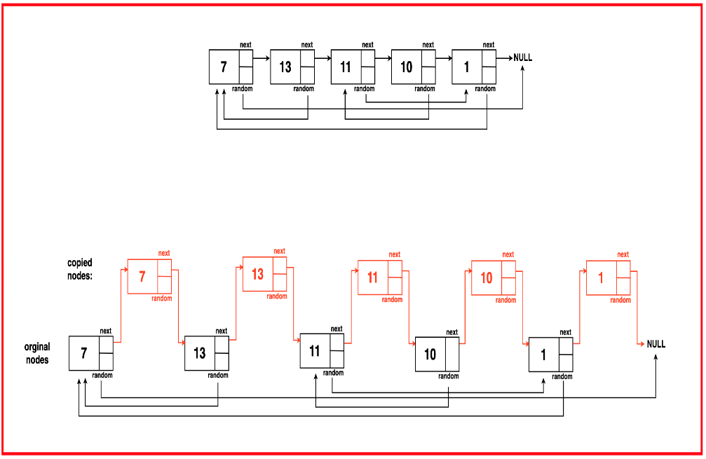
Step 2: Traverse this modified list and for each original node that has a random pointer, set the copied node’s random pointer to the corresponding copies random node. If the original node’s random pointer is full, set the copied node’s random pointe to null as well.
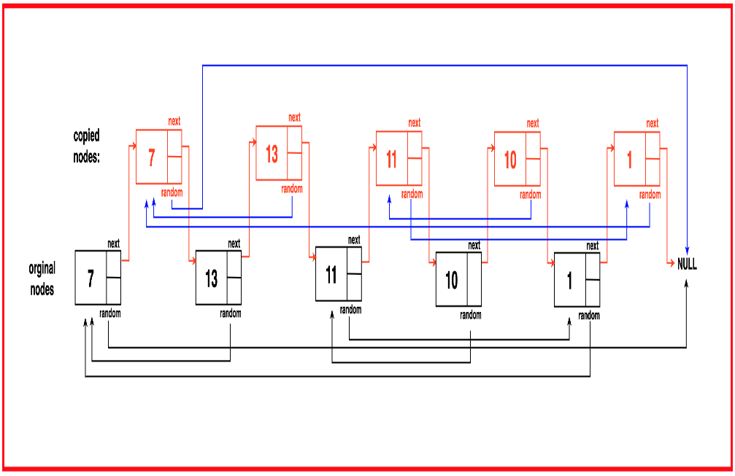
Step 3: Recursion Traverse the modified list again and extract the coped nodes by breaking the links between the original nodes and the copied nodes. Revert the original list to its initial state by fixing the next pointers.
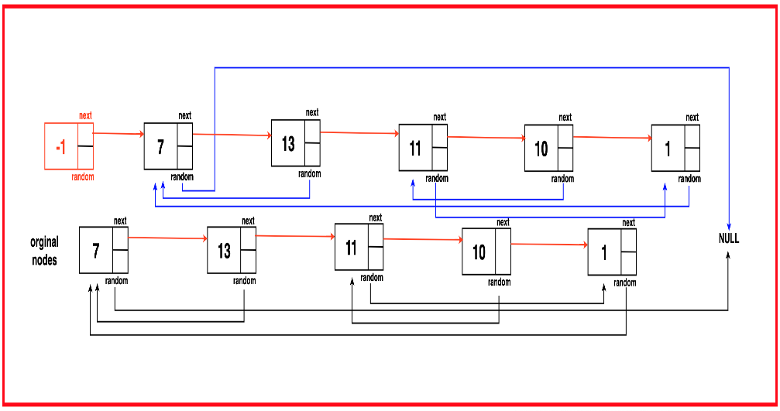
Step 4: Return the head of the deep copy obtained after extracting the copied nodes from the modified list.

class Node {
// Data stored in the node
int data;
// Pointer to the next node
Node next;
// Pointer to a random
// node in the list
Node random;

// Constructors for Node class
Node() {
// Default constructor
this.data = 0;
this.next = null;
this.random = null;
}

Node(int x) {
// Constructor with data
this.data = x;
this.next = null;
this.random = null;
}

Node(int x, Node nextNode, Node randomNode) {
// Constructor with data,
// next, and random pointers
this.data = x;
this.next = nextNode;
this.random = randomNode;
}
}

// Function to insert a copy of each
// node in between the original nodes
void insertCopyInBetween(Node head) {
Node temp = head;
while (temp != null) {
Node nextElement = temp.next;
// Create a new node with the same data
Node copy = new Node(temp.data);

// Point the copy's next to
// the original node's next
copy.next = nextElement;

// Point the original
// node's next to the copy
temp.next = copy;

// Move to the next original node
temp = nextElement;
}
}

// Function to connect random
// pointers of the copied nodes
void connectRandomPointers(Node head) {
Node temp = head;
while (temp != null) {
// Access the copied node
Node copyNode = temp.next;

// If the original node
// has a random pointer
if (temp.random != null) {
// Point the copied node's random to the
// corresponding copied random node
copyNode.random = temp.random.next;
} else {
// Set the copied node's random to
// null if the original random is null
copyNode.random = null;
}

// Move to the next original node
temp = temp.next.next;
}
}

// Function to retrieve the
// deep copy of the linked list
Node getDeepCopyList(Node head) {
Node temp = head;
// Create a dummy node
Node dummyNode = new Node(-1);
// Initialize a result pointer
Node res = dummyNode;

while (temp != null) {
// Creating a new List by
// pointing to copied nodes
res.next = temp.next;
res = res.next;

// Disconnect and revert back to the
// initial state of the original linked list
temp.next = temp.next.next;
temp = temp.next;
}

// Return the deep copy of the
// list starting from the dummy node
return dummyNode.next;
}

// Function to clone the linked list
Node cloneLL(Node head) {
// If the original list
// is empty, return null
if (head == null) return null;

// Step 1: Insert copy of
// nodes in between
insertCopyInBetween(head);
// Step 2: Connect random
// pointers of copied nodes
connectRandomPointers(head);
// Step 3: Retrieve the deep
// copy of the linked list
return getDeepCopyList(head);
}
}
Time Complexity: O(3N) where N is the number of nodes in the linked list. The algorithm makes three traversals of the linked list, once to create copies and insert them between original nodes, then to set the random pointers of the copied nodes to their appropriate copied nodes and then to separate the copied and original nodes.
Space Complexity : O(N) where N is the number of nodes in the linked list as the only extra additional space allocated it to create the copied list without creating any other additional data structures

